**WEEK 8**

**Module 11 – Version control – GIT**

**5.Git-HOL**

**1. Navigate to your working directory**

*cd "D:/CTS/WEEK – 8/Ex5"*

**2. Verify if master is in clean state**

*git checkout master*

*git status*

**3. List all branches**

*git branch -a*

**4. Pull latest changes from remote master**

*git pull origin master*

**5. Push pending changes to remote**

*git push origin master*

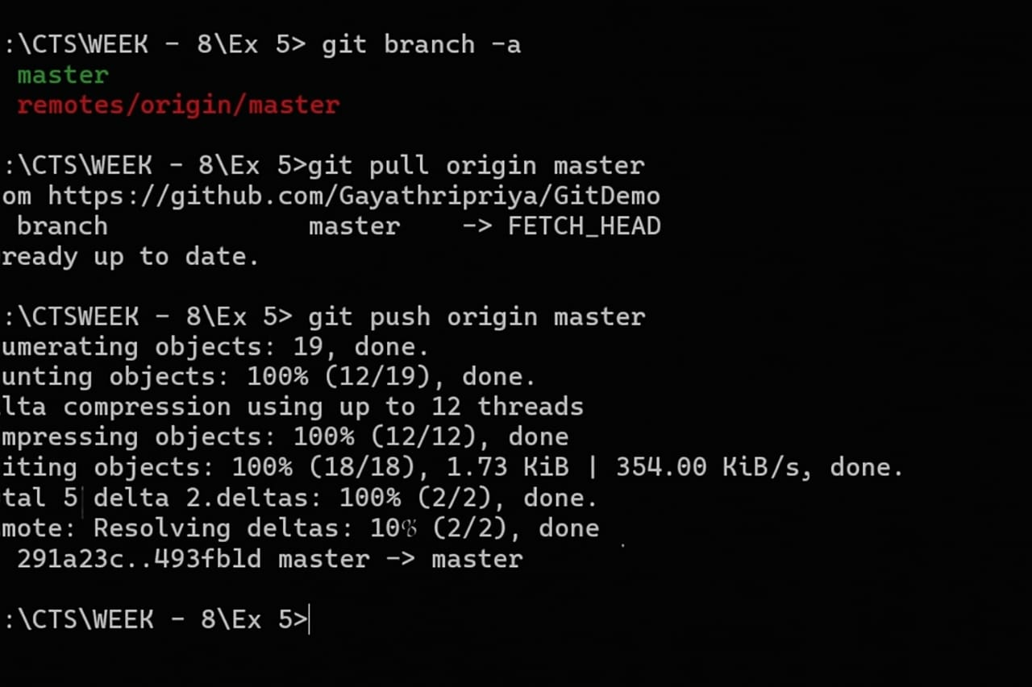**OUTPUT:**